Roll no: 241701021

Experiment 7

Aim:
To design and configure the subnets and check connectivity across machines of the subnets by sending PDU packets.

Components Used:
- 1 Router
- 2 PT Switches
- 6 PCs
- 8 Copper Straight-Through Wire

Ball Diagram:
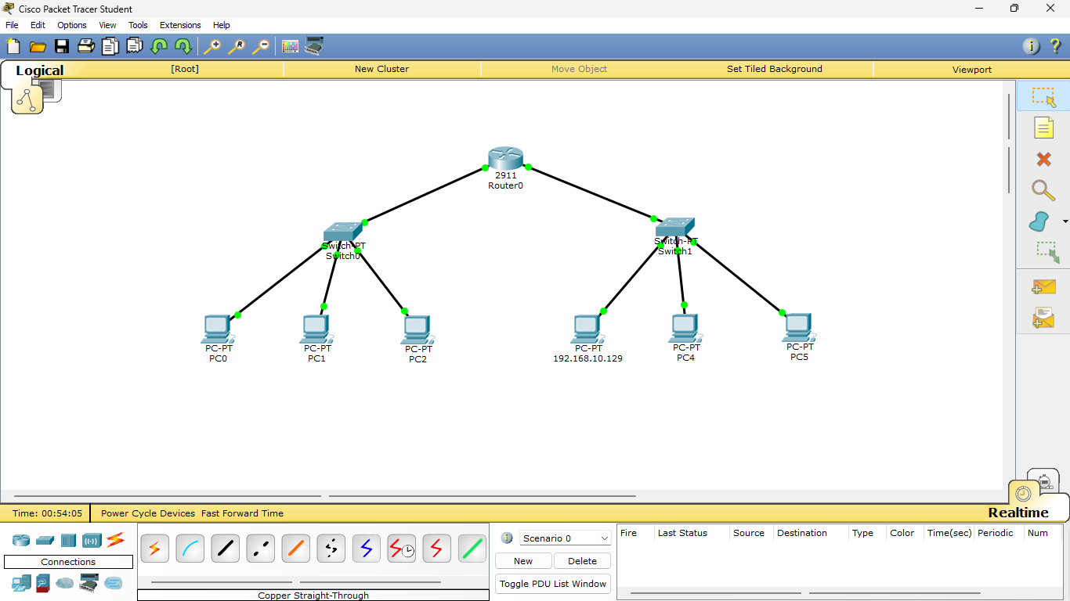

Procedure:

- Connect two PT Switches to a router using a Copper Straight-Through wire through fast ethernet.
- Then connect each Switch with any six End Devices of your choice (PC/Laptop) using a Copper Straight-Through wire through fast ethernet.
- Click on each of the End Devices, go to Desktop and set the respective IP Addresses, Subnet Mask, and Default Gateway.
- Now click on the Router, go to Config, click GigabitEthernet0/0, turn on the Port Status and set the respective IP Address and Subnet mask. Do the same for GigabitEthernet0/1.
- Rename the End Devices as per their respective IP addresses.
- Now, we can click on any End Device, go to Command Prompt in the Desktop tab and type in commands to view the IP configuration, to ping other End Devices, etc.

Observation:
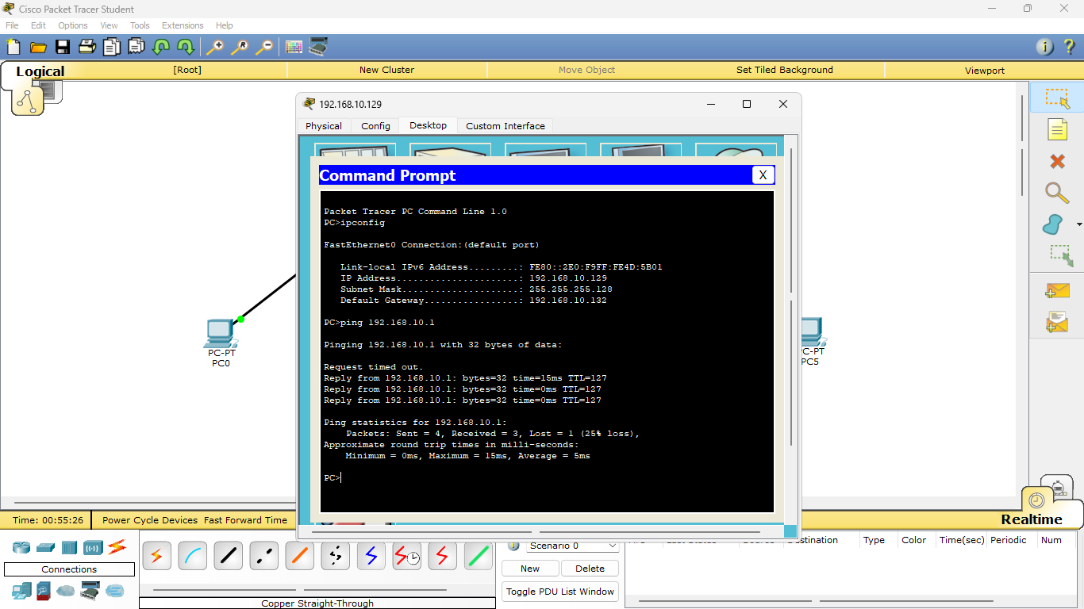

Result:
Thus the design and configuration of the subnets and checking of connectivity across machines of the subnets by sending PDU packets was successfully completed and verified.

